PROJECT PROPOSAL: CareConnect

## **Overview**

We propose to design a user-friendly app to find and book appointments with doctors around you. It also allows users to search hospitals, leave reviews and chat with doctors.

## **Problem Definition**

There’s no app where you can search for hospitals and doctors, as well as book an appointment and chat with the doctors. Patients need to google doctors and hospitals, find their number and call them up for appointments or go to the websites. It’s like how food deliveries happened before UberEats and DoorDash became popular: you search up a restaurant on google, call them up and pay when the food arrives. An app for all hospitals and doctors to create profiles and patients to easily navigate and book appointments would solve this problem.

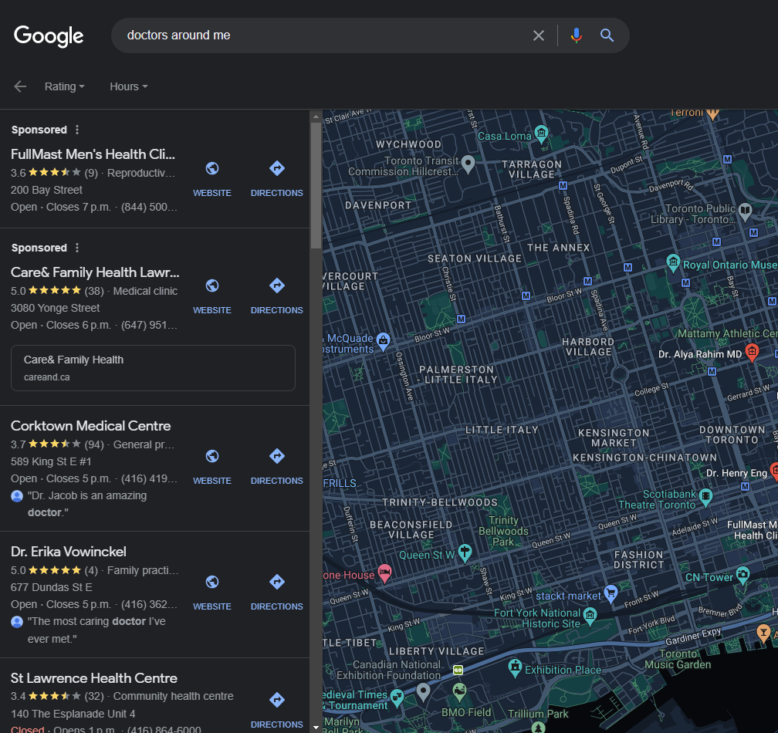

## **Background Research**

1. **Why is there a market and who are potential users?**

Everyone needs a seamless experience when engaging with businesses online, especially patients worried that they might be sick. It’s essential for people to have easy access to detailed information about doctors, including their specialties, credentials, patient reviews, and office locations. Traditional methods of booking appointments, such as calling clinics, can be time-consuming and frustrating. An app can streamline the booking process, allowing users to see available time slots and choose the one that suits them best.

Potential users could be patients, caregivers, medical tourists, doctors and hospitals

1. **Who is the competition and what do they offer?**

* Many healthcare systems and hospitals have their own apps that allow patients to find doctors within their network and book appointments. Examples include the Mayo Clinic app and the Cleveland Clinic app.
* Local directories like Yelp and Google Maps often include healthcare provider information and reviews, making them potential competitors.

1. **What are the strengths and weaknesses of these platforms?**

**Hospital Websites:**

**Strengths**

* Provide detailed information about the hospital's services, facilities, and healthcare providers.
* Some allow direct appointment booking with healthcare providers.
* Often include information about specialized departments and treatments.

**Weaknesses**

* May present a biased view of their own services, limiting comparisons.
* Quality and user-friendliness can vary.
* Not all offer online appointment booking, requiring phone calls.
* Often lack patient reviews, limiting insights into the patient experience.

**Google:**

**Strengths**

* Provides a variety of information about hospitals.
* Can link users to hospital websites or appointment booking platforms.
* Offers quick access to information about specialized care.

**Weaknesses**

* May lack detailed information, making comparisons challenging.
* May not always display appointment availability.
* User experience depends on the quality of website content indexed.

1. **Initial assumed user needs and goals:**

* Seamless booking flow
* Doctor profiles detailing their qualifications, specialties, patient reviews and availability
* Page filters to get best possible results to their queries
* Online consultations

## **ChatGPT Research**

ChatGPT gave us a great detailed summary of our entire research. What we could not get from ChatGPT were sources and reference to back opinions and claims. For this we independently verified and investigated information based on the leads obtained through ChatGPT. It acted as a great tool to point us in the right direction during our research.

## **Product Description**

The proposed app aims to offer 3 major functionalities

1. **Discover Doctors:** To offer a seamless and user-friendly experience for discovering a wide range of healthcare professionals. Whether you're searching for a primary care physician, specialist, or any other medical expert, our aim is to help you find the right doctor to meet your needs.You canget to know your healthcare providers before your appointment. Through this platform we aim to offer detailed profiles of doctors, including their qualifications, specialties, patient reviews, and even personal information. This allows you to make informed decisions and establish trust with your chosen healthcare professional.
2. **Effortless Appointment Booking:** We will be simplifying the appointment booking process to make it as effortless as possible. With just a few clicks, you can schedule appointments with your chosen doctors at a time that suits you. No long waiting queues, no phone calls, no waiting on hold. In-built calendars will also notify users about an upcoming appointment so that they never miss one.
3. **Online Consultations:** Our app would facilitate virtual appointments with healthcare professionals for medical advice, follow-ups, and second opinions. Through secure video calls and chat, users can discuss health concerns, share medical records, and receive expert guidance conveniently from their homes. This feature prioritizes user privacy and accessibility, eliminating the need for in-person visits.

## **Initial Planning**

We will be utilizing Figma to concentrate solely on enhancing the user interface (UI) and user experience (UX) of our application. We will be using Trello to track and distribute tasks. Our iterative design process centers on gathering user feedback to refine the front-end without any backend development involved. This approach ensures we create a visually appealing, user-friendly product that aligns with our users' needs and preferences while streamlining our design process.

## **Contributions**

1. **Habeebuddin Mir (002713929)** - Idea & User Surveys
2. **Shaiz Akhtar (002796856)** - Design & Planning
3. **Maseerah Khatoon (002778147)** - Research & Innovation

**Need to Add in report**  
Well done! Group 4 - CareConnect, for a well-detailed explanation of the current problem and initial user needs/goals Below are some feedback - 1. Not defined the Scope of the project 2. Lack of discussion on why you believe the project can be completed within the semester Keep up the good work! Thanks

Kaushikee Bhawsar, Sep 30 at 6:04pm

you chose a great topic, however you missed out on proper background research. even through there may not be a platform with what you envision, there are many apps with similar scope - it would have been good to review their pros and cons, even based on reviews in the app stores. I really feel that you should do this to help guide your focus for the next assignment and onward.

Svetlena Taneva Metzger, Oct 2 at 2:48pm